LECTURE 3.3.1
TREES
Course outcome to be covered:
CO4: Apply and recognized about the Trees

1.1 INTRODUCTION TO TREES WITH BASIC DEFINATIONS
In this lecture we will study about special type of graphs called trees and the terminologies related to the trees.
1.2 TOPIC OBJECTIVES
- The students will learn about a special type of graphs called trees.
- This topic will help to specific terms related to trees and their applications.
1.3 STRUCTURE:
- Introduction
- Definition and concept of trees
- Basic terminology related to trees
- Numericals
1.4 INTRODUCTION
The concept of trees rises from a special kind of graphs giving rise to the term tree. In this lecture we will discuss trees which are frequently used in various fields of sciences in engineering. The fundamental terminology used in trees will be studied in this lecture to understand the concept.
1.5 TREE
A graph which has no cycle is called an acyclic graph. A tree is an acyclic graph or graph having no cycles.
A tree or general tree is defined as a non-empty finite set of elements called vertices or nodes having the property that each node can have minimum degree 1 and maximum degree n. It can be partitioned into n+ 1 disjoint subsets such that the first subset contains the root of the tree and remaining n subsets includes the elements of the n sub tree. The figure 1 below represents a general tree:

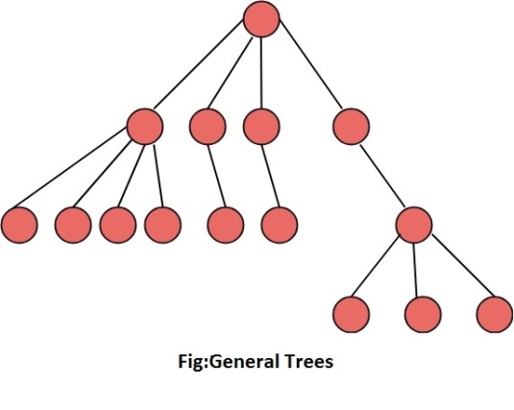Fig 1
1.6 BASIC TERMINOLOGY:
1) Root: A binary tree has a unique node called the root of the tree. See fig 2 below
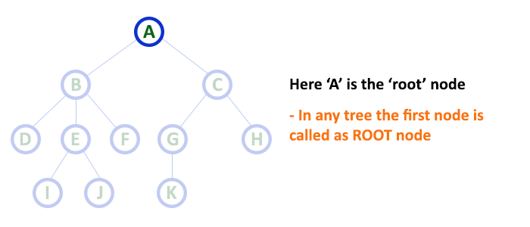Fig 2
2) Left Child: The node to the left of the root is called its left child.
3) Right Child: The node to the right of the root is called its right child.
4) Parent: A node having a left child or right child or both are called the parent of the nodes. See fig 3 below
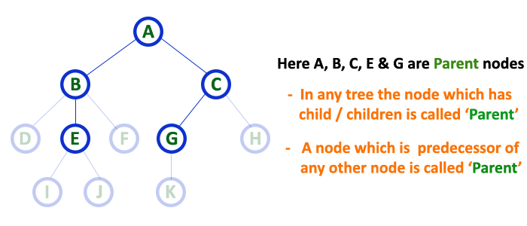
Fig 3
5) Siblings: Two nodes having the same parent are called siblings. See fig 4 below
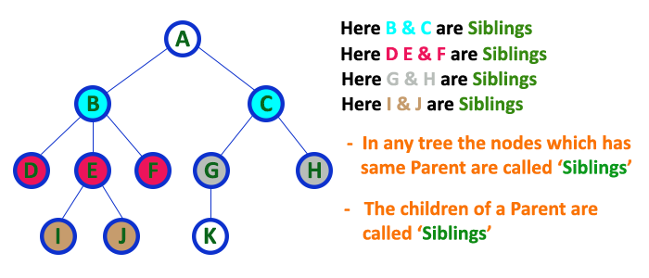Fig 4
6) Leaf: A node with no children is called a leaf. The number of leaves in a binary tree can vary from one (minimum) to half the number of vertices (maximum) in a tree. See fig 5 below
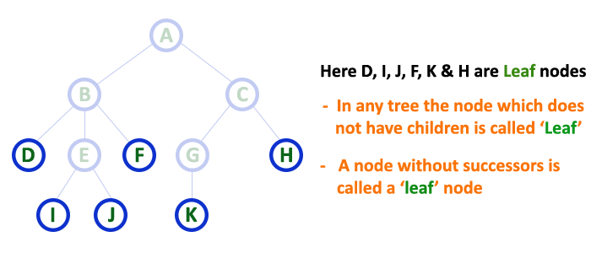Fig 5
7) Ancestor: If a node is the parent of another node, then it is called ancestor of that node. The root is an ancestor of every other node in the tree.
8) Descendant: A node is called descendant of another node if it is the child of the node or child of some other descendant of that node. All the nodes in the tree are descendants of the root.
9) Left Sub tree: The sub tree whose root is the left child of some node is called the left sub tree of that node.
10) Right Sub tree: The sub tree whose root is the right child of some node is called the left sub tree of that node.
11) Level of a node: The level of a node is its distance from the root. The level of root is defined as zero. The level of all other nodes is one more than its parent node. The maximum number of nodes at any level n is 2^{n}. See fig 6 below
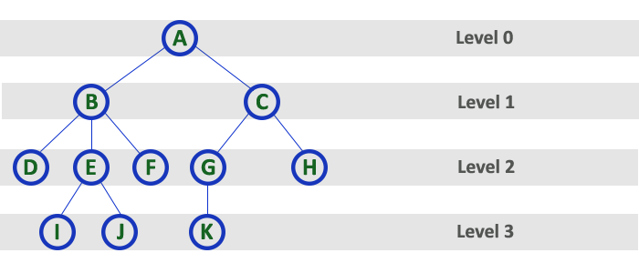fig 6
12) Depth or Height of a tree: The depth or height of a tree is defined as the maximum number of nodes in a branch of a tree. This is more than the maximum level of the tree, i.e., the depth of root is one. The maximum number of nodes in a binary tree of depth d is 2^{d}-1, where d ≥1. See fig 7 below
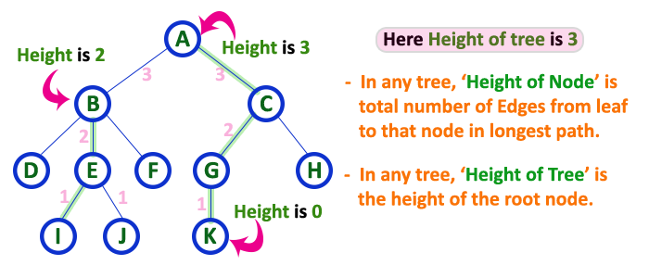Fig 7
External nodes: The nodes which have no children are called external nodes or terminal nodes.
Internal nodes: The nodes which have one or more than one children are called internal or non- terminal nodes.
Example: For the tree as shown in fig 8
- Which node is the root?
- Which nodes are leaves?
- Name the parent node of each node
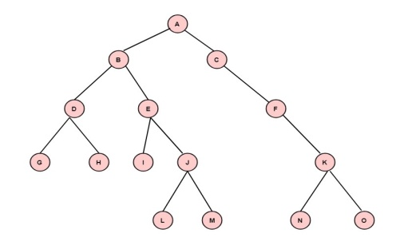 Fig 8
Solution: (i) The node A is the root node.
(ii) The nodes G, H, I, L, M, N, O are leaves.
(iii) Nodes Parent
B, C A
D, E B
F C
G, H D
I, J E
K F
L, M J
N, O K

1.7 Path length of a Vertex
The path length of a vertex in a rooted tree is defined to be the number of edges in the path from the root to the vertex. See fig 9 below
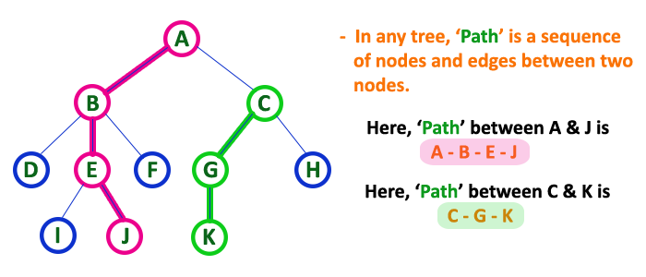Fig 9
Example: Find the path lengths of the nodes b, f, l, q as shown in fig 10 below:
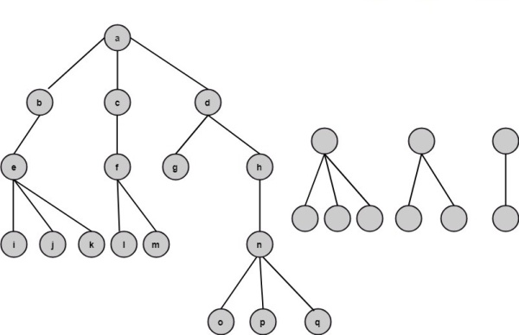Fig 10
Solution: The path length of node b is one.
The path length of node f is two.
The path length of node I is three.
The path length of node q is four.
Example: For the tree shown in fig 11 below
- List the children of each node.
- List the siblings.
- Find the depth of each node.
- Find the level of each node.
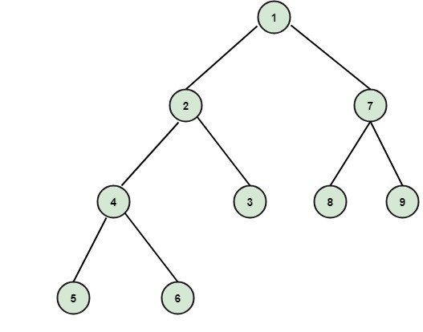
Fig 11
Solution: (i) The children of each node is as follows:
Node Children
1 2, 7
2 4, 3
4 5, 6
7 8, 9
(ii) The siblings are as follows:
2 and 7 are siblings.
4 and 3 are siblings.
5 and 6 are siblings.
8 and 9 are siblings.
(iii) The depth of each node is
Node Depth
1 1
2, 7 2
4, 3, 8, 9 3
5, 6 4
(IV)The level of each node is
Node Depth
1 0
2, 7 1
4, 3, 8, 9 2
5, 6 3
Summary
The points discussed in this lecture are summarized below:
- The introduction to trees which is a special type of graph.
- A graph which has no cycle and is connected is a tree with some properties.
- The fundamental terms used in trees like root, leaf, children, depth and level nodes in a tree.
- The path length of vertices in rooted trees.
Frequently asked questions
Q1 what is a tree in math?
ANS. A tree is a set of straight line segments connected at their ends containing no closed loops (cycles). In other words, it is a simple, undirected, connected, acyclic graph (or, equivalently, a connected forest). A tree with nodes has graph edges. Conversely, a connected graph with nodes and. edges is a tree.

Q2 what is tree diagram example?
ANS. A common example used to introduce tree diagrams is to find the number of possible outcomes of flipping two coins in succession. ... Our tree diagram displays all the possible outcomes of flipping two coins in succession. Each path of branches represents one outcome.

REFERENCES

WEB LINKS

1 http://www.btechsmartclass.com/data_structures/tree-terminology.html

2 http://courses.ics.hawaii.edu/ReviewICS241/morea/trees/Trees-QA.pdf

VIDEO LINKS

1 https://youtu.be/orKlYmj5AZY

2 https://youtu.be/-QVoF12pnq8

Applications

Heap is a tree data structure which is implemented using arrays and used to implement priority queues. B-Tree and B+ Tree: They are used to implement indexing in databases. Syntax Tree: Used in Compilers. K-D Tree: A space partitioning tree used to organize points in K dimensional space.
In computer science, a tree is a widely used abstract data type (ADT) that simulates a hierarchical tree structure, with a root value and sub trees of children with a parent node, represented as a set of linked nodes.

Practice questions
Q1 List the root, leaf children and siblings in the following tree.
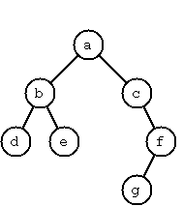fig A
Q2 In fig A shown above write the level and depth of each node.

